BALUNG
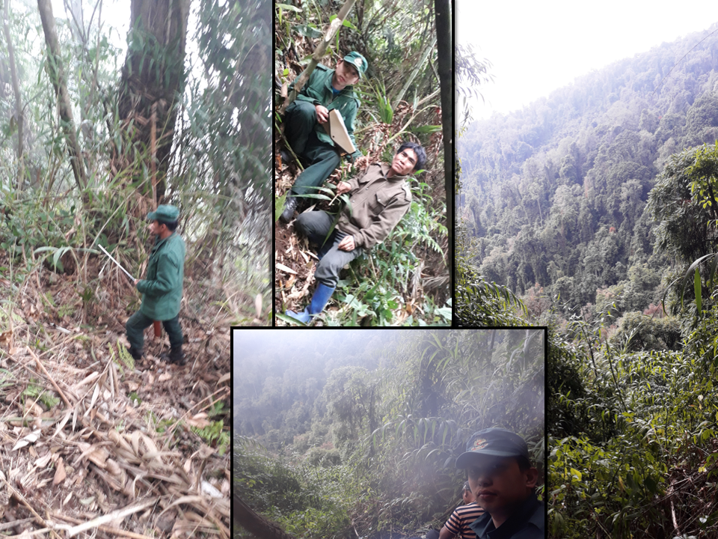
Non-Wood Forest Produce Management & Marketing Group
Lajab Gewog, Dagana Dzongkhag
Plan Period: 2021-2026

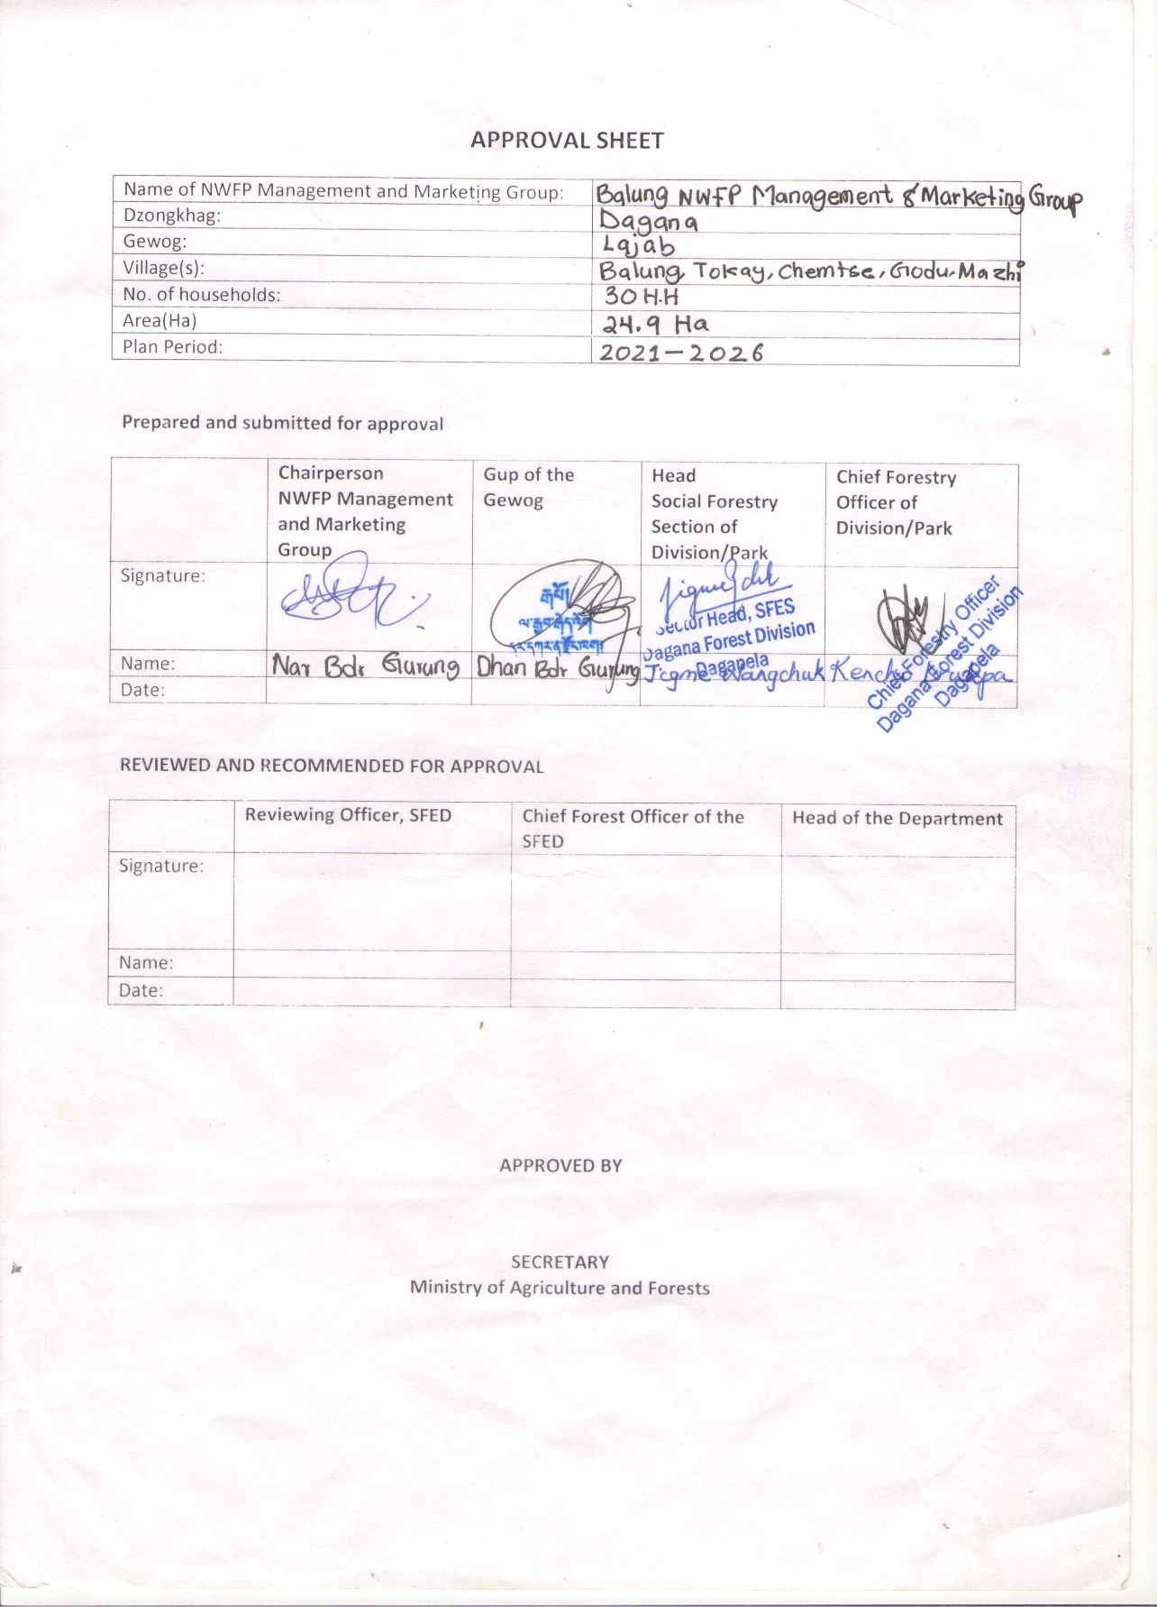
Approval Sheet
Contents

Approval Sheet i
Part A: NWFP Management and Marketing Plan 1
1. Background 1
1.1. Goals and Objectives 2
1.2. Description of the NWFPs 2
2. Harvesting prescription for Plectocomia himalayana 4
3. The NWFP Collection Area 6
4. Marketing and Sales Plan 6
5. Marketing arrangement 7
6. Benefits to the members 7
7. Cane Resource assessment 8
8. Analysis of Resource Assessment Data 8
9. Annual Harvesting Limits 8
9.1. Annual Harvesting Limits of Canes in number of stems and backloads over a time period of 10 years for block I (Canes) 9
9.2. Annual Harvesting Limits of Canes in number of stems and backloads over a time period of 10 years for block II (Canes) 10
9.3. Annual Harvesting Limits of Canes in number of stems and backloads over a time period of 10 years for block III (Canes) 11
PART B: By-Laws: Group Regulations and Norms 12
10. Members of the NWFP management & marketing group 12
11. Executive committee 13
11.1. Chairperson 13
11.2. Secretary 13
11.3. Treasurer 14
12. Compensation for the executive Committee members 14
13. Membership Fee and purpose 14
14. Community development fund and utilization of fund 15
15. Conflict Resolution 15
16. Penalties 16
17. Authority of the Department 16
18. Cancellation of NWFP Management Certificate 17
19. Annexure I: NWFP Group Membership list 18
20. Annexure II: Block description form for canes 20
21. Annexure III: Data Compilation Sheet 23
22. Annexure IV: Application for the establishment of NWFP group from Gewog Administration 25
23. Annexure V: List of Non-Wood Forest Product 26

Part A: NWFP Management and Marketing Plan

Background
The Balung Chiwog is located in an extreme end of Lajab Gewog under Dagana Dzongkhag. The Chiwog has a total 36 households with ethnic composition of Ngalops, Sharshops, and Lhotshompas. The people of this chiwog mainly grow paddy, buckwheat and vegetables at their backyard following crop-rotation technique. Cardamom is the main cash crop grown by most of them but some of them even grows vegetables in small scale as a cash crop. As the village is located at the heart of the forested area, it harbors high stock of the NWFP products such as the ferns, dumroo (Elatostema lineolatum), bamboos, brooms, mushrooms, and cane.
They rear cattle and oxen, which is the source of the dairy products and as draught animal respectively. The people in the Chiwog depend on forests for their livelihood, as it’s the source of timber, fuelwood, fodder and other wild vegetables.
As per the locals, around 27 backloads, which is one backload per household in average of the cane shoots have been collected every year, which is used as food in their community and used for making various utensils. The availability of cane naturally in the wild gives them an advantage of harnessing different products with local’s expertise on few items such as baskets and ropes which can be sold in the near market in adjacent Dzongkhag such as Thimphu and Wangdue, if market is linked. The cane shoots (also patsa) are used as food; most commonly in the various occasions such the rituals and marriages parties.
Currently, they have given more of the focus to the shoots as it can be readily sold in the market without much of the value addition rather than the production of the handicrafts as they lack the skills for the production.
To reduce the exploitation and the overharvesting of the resource, the people residing adjacent to the forest has planned for the development of the NWFP management plan. The plan will help them in term of the sustainable harvesting of the resources and generation of income from the forest resources. With the creation of the NWFP Management Plan, they are hoping to increase the production with the creation of the nursery. It can also add to the income generation and employment opportunities.
Before commencing the work, consultation meeting with Gewog involving all the members was done for the demarcation of the boundary, resource inventory, management area and the discussed on the future opportunities.

Goals and Objectives
  - Sustainable Harvesting of the resources
  - Proper marketing Channel
  - Enhancement and development of value-added products in the future.

Description of the NWFPs
The management regime for NWFPs harbors various NWFPs such as Dumroo (Elatostema lineolatum), different species of edible mushrooms, Thingay (Zanthoxylum spp.), various species of bamboo and two cane species (mainly dominated by Plectocomia himalayana). They also harvest the ferns and mushrooms as a source of food. The ferns and dumroo are largely collected by almost every household for self-consumption and if in surplus, for commercialization. In the harvesting season, the mushrooms and thingay are also collected, however, for the self-consumption.
Plectocomia himalayana also known as the Patsa in Dzongkha, Phasey in Sharshop, Ray in Kheng and Gouri Bet in Lhotshompa has an altitudinal range from 1200 to 2150 m (Guidlines for resource assesment and management of Cane, 2011).
The canes which are L>20m (cane>10m) are considered as mature canes, canes which are L>20m (cane>10m) are considered as Semi-mature canes, the 10-20m length and 2-<10mlength are considered as sapling and the canes with <2m length are considered as suckers/seedling.
As per the survey, more canes are lying on the ground than the canes that are crawling on the trees. The cane shoot shall be collected in the late spring and summer seasons and the canes shall be collected in the winter months.

Table 1. Brief description of NWFPs for commercial harvesting
NWFP Name | Harvesting Area | Parts harvested | Use Purpose (traditional & others) | Harvesting season (month) | Estimated quantity that can be collected
Plectocomia Himalayana | Balung unrestricted Forest | Young Shoots & Matured Canes | Shoots used as food  Matured canes for the handicrafts | Winter for the Handicraft purpose  Summer for cane shoots | 100 backloads  50 backloads

Harvesting prescription for Plectocomia himalayana
Sl.no | Name |  | Parts used | Uses | Purpose |  | Time of Harvesting | Guidelines for harvesting
 | Scientific | Local |  |  | Domestic | Export
1 | Plectocomia himalayana | Patsa (Dz) | Young shoot as well as matured stem | Young shoot as vegetable  Mature stem used to produce handicraft items | Yes | - | Winter time for mature stem | For Mature stems:  Cut cane stem only when mature, to be recognized by:  - Loosening of leaf sheath from the lower part of the cane stem  - Exposure of lowest part of the stem  - Turning to yellowish-reddish along the entire stem length  - Diameter over the entire length of the cane is the same (the diameter at the lower part of the cane is reduced)  - Pull down as much of the stem as possible (avoid leaving cane parts high up in the tree)  - Cut only canes with a usable length of at least 10m. Discard at maximum 1.2 to 1.5 meters from the top end.  Harvest during winter as canes have a better quality during this season (lower water content and more durable).  For cane shoots  - Cut young shoots by bending the cane stem with the help of a long and strong stick with a hook.  - Do not cut the entire cane to collect the shoots. Cut the leading shoot with a sharp knife diagonally (not straight in order to avoid rotting of the remaining stump); leave lateral shoots.  - Care shall be taken to avoid damaging sucker buds (these will later develop into lateral shoots)  Guidelines for both mature stems and cane shoots  - Uprooting, cutting of rhizomes/suckers shall be avoided  - Trees supporting the canes shall not be felled  - The debris after harvesting canes should be taken outside the cane area in order to avoid infection with insect borers or fungi

The NWFP Collection Area
The map below is the NWFP management area of the Balung. It is divided into three blocks.
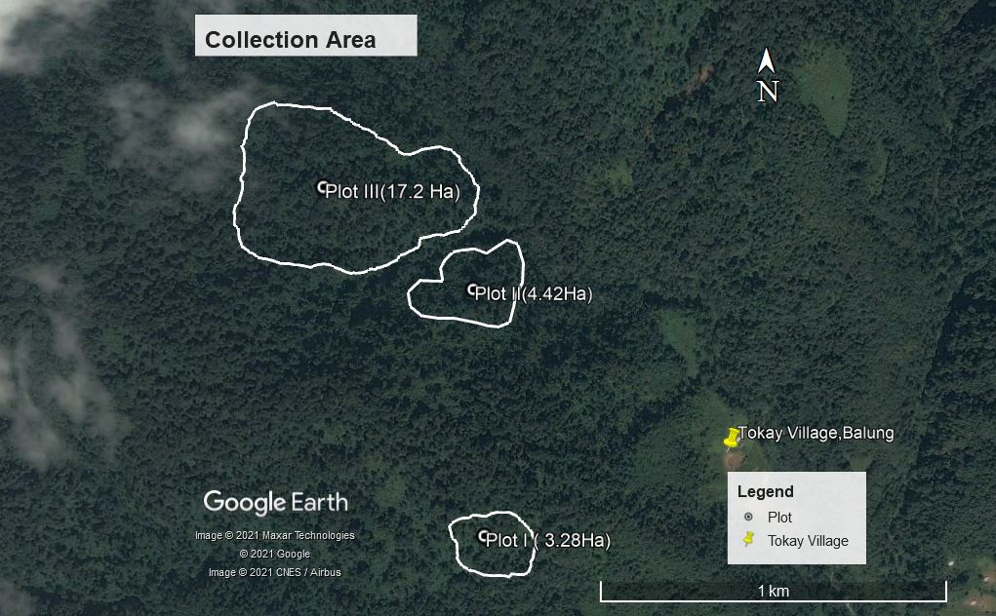

Marketing and Sales Plan
The potential markets for the sale of the canes and its products are Thimphu, Wangdue, Dagana and Tsirang. The canes can be sold in two forms: Shoots are sold directly after harvesting and resizing, while the products of the canes are converted into handcraft. The product can also be sold to the nearby handicraft house that the Gewog has recently constructed.

Table 2. Marketing and Sales Plan
NWFP | Potential  Market | Estimated quantity for sale per season (unit) | Expected price per unit | Total (Nu.) | Remarks
Cane shoots (Plectocomia himalayana) | In-country, mostly Thimphu and Wangdue | 500 | Nu.30/unit to members | 15000/- | 5% of the amount shall go into the Management Group Account.
Canes (Plectocomia himalayana) | In-country, mostly Thimphu and Wangdue | 600 | Nu.100/unit | 60,000/- | 5% of the amount shall go into the Management Group Account.
Note: The Price of the product shall be fixed from time to time as per meeting when selling to the outsider after receiving an order.

Marketing arrangement
After the analysis of the market by the CFMG chairman, the Chairman shall then instruct the members (group) to go to the site for the collection of the NWFP. Before the collection of the NWFP, the collector shall pay all the necessary fees and get the documents for the collection.

Benefits to the members
- The members registered in the group shall have the right for collection and marketing of the NWFP as per the guidelines of the Management group.
- Each member has right to get equal share from the accumulated group fund.

Cane Resource assessment
The cane resource assessment was done with the help of the QGIS. The sampling intensity used was 5% or more. The area was first demarcated after the consultation with the user group with the help of the GPS device in the real field, which was later converted into shape file in the QGIS.
The shape file was then inserted in the Q-GIS and the plotting was done. The regular plots were plotted using sampling intensity of 5% or more. The plots were then again inserted into the GPS device for the resource assessment.

Analysis of Resource Assessment Data
The data collected in the field is analyzed using the excel sheet where the data of the canes in the different sizes are entered into the different column. After entering the data, area of the total sample plot is drawn. Then the total canes or shoots of the different class group is then drawn, which is then divided into each sample plots where the data are extrapolated and then the annual harvesting limit of each sample class is drawn.

Annual Harvesting Limits
The sucker and the immature (2-<10m length) has been clubbed together as suckers as it has to be retained for growth. Mature cane category shall be collected in the time period within 10 years for canes in the first Management Plan period. Semi-mature canes and immature canes category shall be harvested for the shoots in the time period of 10 years. The suckers and the cane category of the semi-mature and immature shall be left for the growing that shall replace the one that are harvested.

Annual Harvesting Limits of Canes in number of stems and backloads over a time period of 10 years for block I (Canes)
Block I
Block Area in acres/Ha = 3.28 Ha/ 8.11 Acres (a)
Total Sampling area covered in acres = (no of sample plots in block x sample plot size)/10,000
= (4 plots x 500.34 m²)/10,000
= (0.200136 x 2.471) = 0.494 Acres (b)
Time period for harvesting canes for handicrafts/cane shoots | Cane species | No. of canes in sampling area (c) | No. of canes per acre (d) = c/b | AHL of cane stems per block (e) = a x d | AHL of canes per block
Mature Canes  Year 1- 2  (L>2m(cane>10m) | Plectocomia  himalayana | 150 | 304 | 2466 | 247
Year 3-4, Semi-mature cane>20m (cane<10m) Length  Canes | Plectocomia  himalayana | 61 | 124 | 1006 | nil
Year 3-4, Semi-mature cane>20m (cane<10m) Length  Shoots | Plectocomia  himalayana | 10 | 20 | 164 | 16
Immature canes  Years 5-6 years (10-20m)  Canes | Plectocomia  himalayana | 2 | 4 | 33 | Nil
Immature canes Year 5-6 (10-20m)  Shoots | Plectocomia  himalayana | 67 | 136 | 1202 | 120
Suckers Year 7-10 (Present <2m) | Plectocomia  himalayana | 207 | 422 | 3422 | Nil

Annual Harvesting Limits of Canes in number of stems and backloads over a time period of 10 years for block II (Canes)
Block II
Block Area in acres/Ha = 4.42 Ha/ 10.9 Acres (a)
Total Sampling area covered in acres = (nos of sample plots in block x sample plot size)/10,000
= (5 plots x 500.34 m²)/10,000
= (0.25017x 2.471) = 0.62 Acres (b)
Time period for harvesting canes for handicrafts/cane shoots | Cane species | No. of canes in sampling area (c) | No. of canes per acre (d) = c/b | AHL of cane stems per block (e) = a x d | AHL of canes per block
Mature Canes  Year 1- 2  (L>2m(cane>10m) | Plectocomia himalayana | 74 | 119 | 1297 | 130
Year 3-4, Semi-mature cane>20m (cane<10m) Length  For Canes | Plectocomia himalayana | 13 | 21 | 229 | nil
Year 3-4, Semi-mature cane>20m (cane<10m) Length  For Shoots | Plectocomia himalayana | 15 | 24 | 264 | 26
Immature canes Year 5-6 (10-20m)  For Canes | Plectocomia himalayana | 73 | 118 | 1286 | Nil
Immature canes Year 5-6 (10-20m)  For Shoots | Plectocomia himalayana | 74 | 119 | 1297 | 129
Suckers Year 7-10 (Present <2m) | Plectocomia himalayana | 166 | 210 | 2289 | Nil
Note: The Immature shoots has been allocated for harvesting whereas the immature canes have not been allocated for harvesting, as it needs to get to good size and form for cane harvesting.

Annual Harvesting Limits of Canes in number of stems and backloads over a time period of 10 years for block III (Canes)
Block III
Block Area in acres/Ha = 17.2 Ha/ 42.5 Acres (a)
Total Sampling area covered in acres = (no of sample plots in block x sample plot size)/10,000
= (18 plots x 500.34 m²)/10,000
= (0.900612x 2.471) = 2.23Acres (b)
Time period for harvesting canes for handicrafts/cane shoots | Cane species | No. of canes in sampling area (c) | No. of canes per acre (d) = c/b | AHL of cane stems per block (e) = a x d | AHL of canes per block
Mature Canes  Year 1- 2  (L>2m(cane>10m) | Plectocomia himalayana | 155 | 70 | 2954 | 295
Year 3-4, Semi-mature cane>20m (cane<10m) Length  For canes  For Canes | Plectocomia himalayana | 99 | 44 | 1887 | Nil
Year 3-4, Semi-mature cane>20m (cane<10m) Length  For Shoots | Plectocomia himalayana | 68 | 31 | 1296 | 129
Immature canes Year 5-6 (10-20m)  For Canes | Plectocomia himalayana | 94 | 42 | 1791 | Nil
Immature canes Year 5-6 (10-20m)  For Shoots | Plectocomia himalayana | 88 | 40 | 1677 | 168
Suckers Year 7-10 (Present <2m) | Plectocomia himalayana | 308 | 138 | 5869 | Nil
Note: The Immature shoots has been allocated for harvesting whereas the immature canes have not been allocated for harvesting, as it needs to grow for harvesting.

PART B: By-Laws: Group Regulations and Norms
Members of the NWFP management & marketing group | Village | Number of member households | Gewog
 | Balung, Tokay, Mazhi, Godu, and Chemchi | 30 HHs | Lajab
Responsibilities and rights of members:
- Every household with definite Gung and Thram from Balung chiwog are eligible to become a member of NWFP Management Group.
- Each member will contribute sum of Nu.100 (one hundred) only as annual membership fee in the month of January every year.
- If the separated person from same Gung wants to become as new member, they can do so upon realizing of normal annual membership fee only/-
- If he/she happened to withdraw from the membership, the group will not entertain any benefits and NWFPs resources collection from the Management area.
- During the time when new non-members want to join a short meeting shall be held for the necessary discussion.
Responsibilities of members:
- Actively participate in general assembly to be held once in a year.
- Collect NWFPs and inform/hand over to committee for proper record and marketing.
- Support the chairperson and committee members to protect the resources from illegal activities.
- Ensure sustainable harvesting of NWFPs resources.

Executive committee
Chairperson | Name of Chairperson: Nar Bdr Gurung.
Responsibilities:
- Chair the meeting related to NWFPs management, utilization and marketing.
- Work in close coordination with other organizations, sectors and agencies, and seek assistance for the development of management group.
- To obtain permit for the sale of group’s/individual’s handicraft items and other NWFPs from CFO.
- Represent the group in meetings that will take place in other parts of the country and share new information and ideas acquired from the meeting with the group members on his return.
- Resolve disputes and conflicts arising among the group members and maintain good working relations.
- Coordinate the patrolling from time to time involving the members.
- Initiate annual planning with committee members and present to the group members during general assembly.
- Jointly sign with the Secretary and Treasurer on the cheque during the withdrawal of community fund.
Secretary | Name of Secretary: Tsheten Zangpo
Responsibilities;
- Officiate chairperson.
- Inform the date, time and venue of meeting to all the group members.
- Keep minutes of NWFPs related meetings and make presentation at the end.
- Assist the chairperson in solving conflicts arising among members and maintain good working relations, and also in marketing of NWFPs.
- Keep proper record and data of NWFPs collected and marketed.
- Jointly sign with the Chairperson and Treasurer on the cheque during the withdrawal of community fund.
- Prepare monthly/quarterly or annual progress report and submit to the CFO.
Treasurer | Name of Treasurer: Krishna Bir Gurung
Responsibilities Treasurer:
- Keep proper records and accountings of NWFPs and assist the chairperson and secretary in marketing.
- Issue a receipt to the individual for quantity of NWFPs collected for sale.
- Keep annual financial transaction records and present to the group members during the general assembly.
- Collect and deposit the money in the NWFPs group account maintained with the nearest financial institution.
- Jointly sign with the Chairperson and Secretary on the cheque during the withdrawal of community fund.
- Prepare financial report and submit to the CFO as and when asked.
Compensation for the executive Committee members | The committee members will serve for three years without any incentives. But if there are opportunities trainings from the Government and other agencies, priority will be given to them as an incentive. It will be given turn wise if it is not work specific.
Membership Fee and purpose | Every member shall contribute annual membership fee of Nu. 50 (fifty) only. The amount will be deposited in the nearest bank and utilized the accumulated amount for the welfare of the NWFPs group members in the near future. The collect amount shall be used in case in any meeting or other activities of the group.

Community development fund and utilization of fund | The community development fund will be generated through deduction of certain percentage from the sale amount of NWFPs and handicraft items.  - For handicraft items, the deduction will be 10% of the total amount earned from each individual or as a whole after the marketing or sale of products.  - The fund shall be utilized for the welfare of NWFPs group members only.  - During emergencies (death), natural calamities etc., reasonable amount will be given to the victim as “semso” upon discussion/meeting with the community.  - In case of utilization of the fund a small discussion/meeting shall be held and the utilization of the fund shall be approved which shall then be used and later the bill/memo shall be presented to the group in the annual meeting.
Conflict Resolution | - The chairperson and executive committee members shall solve the conflict arising among the group members.  - If the conflict arises between executive committee members and the group members, the matter shall be forwarded to Gewog administration and Range office, which in unable to solve shall further be forwarded to the Higher Authority.  - If the problem arises between group members and other communities, the matter shall directly forward to Geog Administration for settlement, and if it is not solved at gewog level, matter shall be further forwarded to the Dzongkhag Administration.

Penalties | Collection or harvesting of NWFPs for home consumption purposes will remain free of royalty while for the sale of NWFP including handicraft items shall require permit from CFO.  Fines and penalties against the illegal activity within the Management area;
- NWFPs collection by him/her without the permission will be fined as per FNCRR, 2017, 2020 and 2021 and the products shall be seized.
- The fine should be paid off within 30(thirty days), in case if failed, it shall be forwarded to Gewog Administration/Forest office/court or stopped him/her from availing the resources from the forest by the community through general assembly.
- Absent fees during meeting Nu.200
In case, a member of the NWFP Group violets the harvesting rules as set in this plan, he or she will not be allowed to harvest the NWFP anymore for the rest of the season and the next season.
 | If there is any offence that is not mentioned above, it shall be dealt as per the latest rules and regulation of the Department of Park and Services.
Authority of the Department | As per Chapter III, section 155 of FNCRR, 2017, the Department shall:  - Suo moto or on the request by the Non-wood Forest Management Group (NWFMG) take action against violator of the Act, Rules or Management Plan;  - Inspect, monitor, review the records of and otherwise supervise the activity of the NWFMG; and  - Take action including cancellation of the NWFMG certificate if the NWFMG or any of its members who violate the provision of the Management Plan or any provision under this Chapter

Cancellation of NWFP Management Certificate | As per Chapter III, section 156, 157 & 158 of FNCRR, 2017:  - The certificate shall be cancelled, if the performance of NWFMG is not as per prescriptions of the approved management plan or the sustainability of the resource is not ensured  - In the event the members of the NWFMG decide to cancel NWFP Management certificate in accordance with this Rules, the NWFP Management Certificate shall be deemed cancelled on the date of such decision being notified to CFO in writing and the NWFMG shall  - Surrender the Certificate to the Department  - The CFO shall have the right to enquire about the reason for such cancellation to ensure that no offence has been committed and shall notify the NWFMG on the cancellation of the certificate.

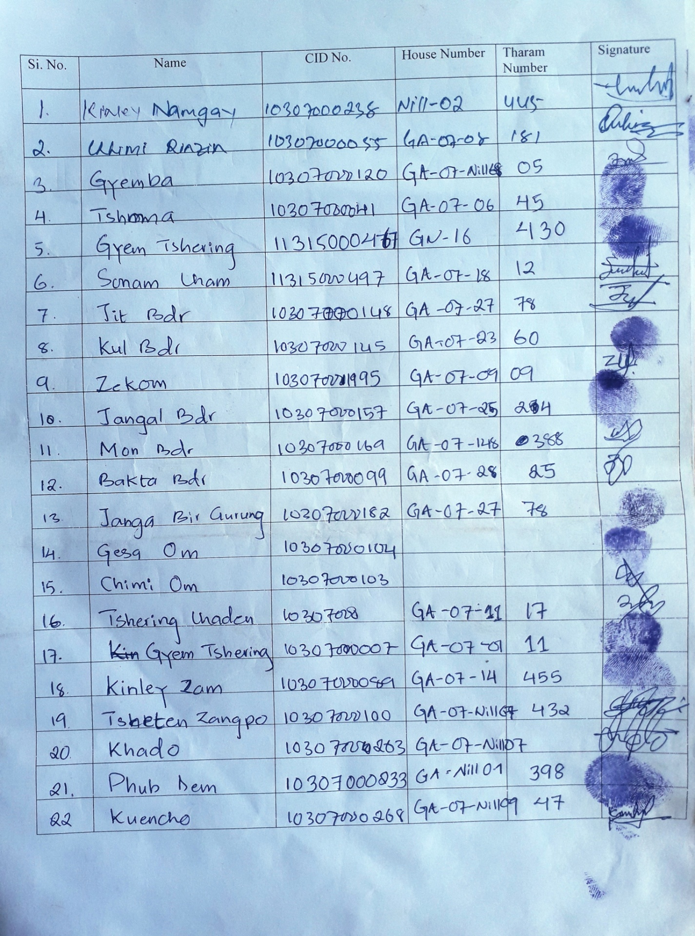
Annexure I: NWFP Group Membership list
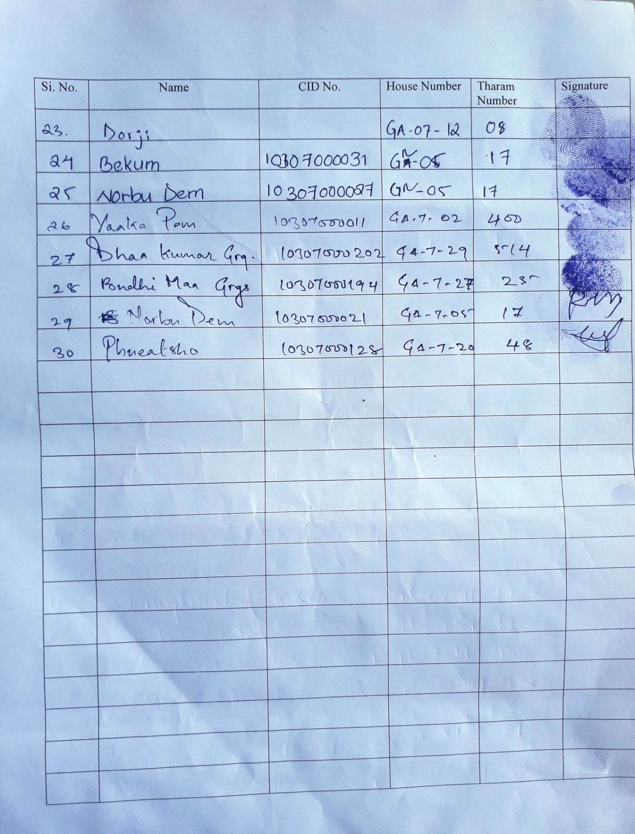

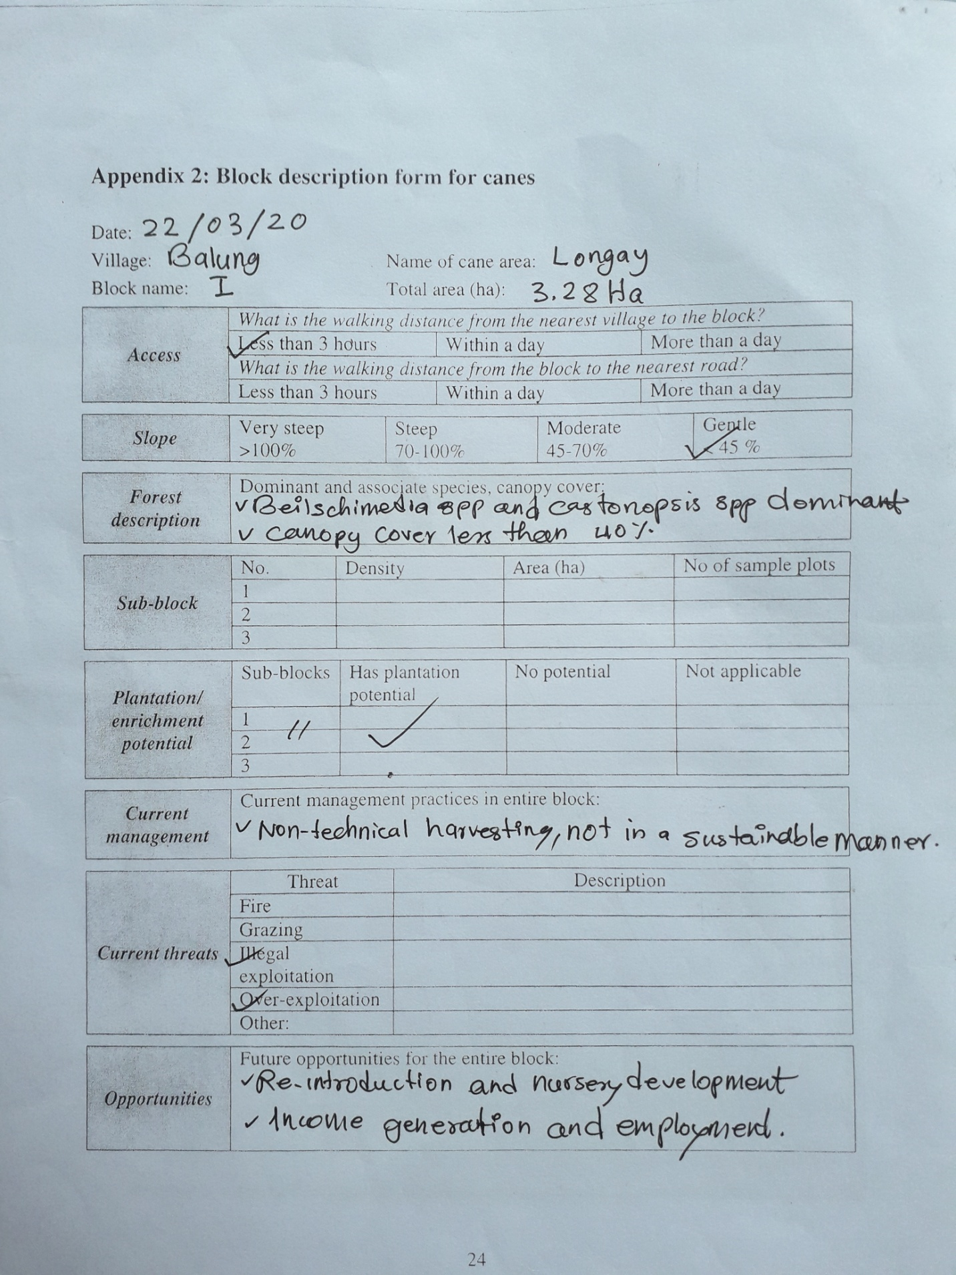
Annexure II: Block description form for canes
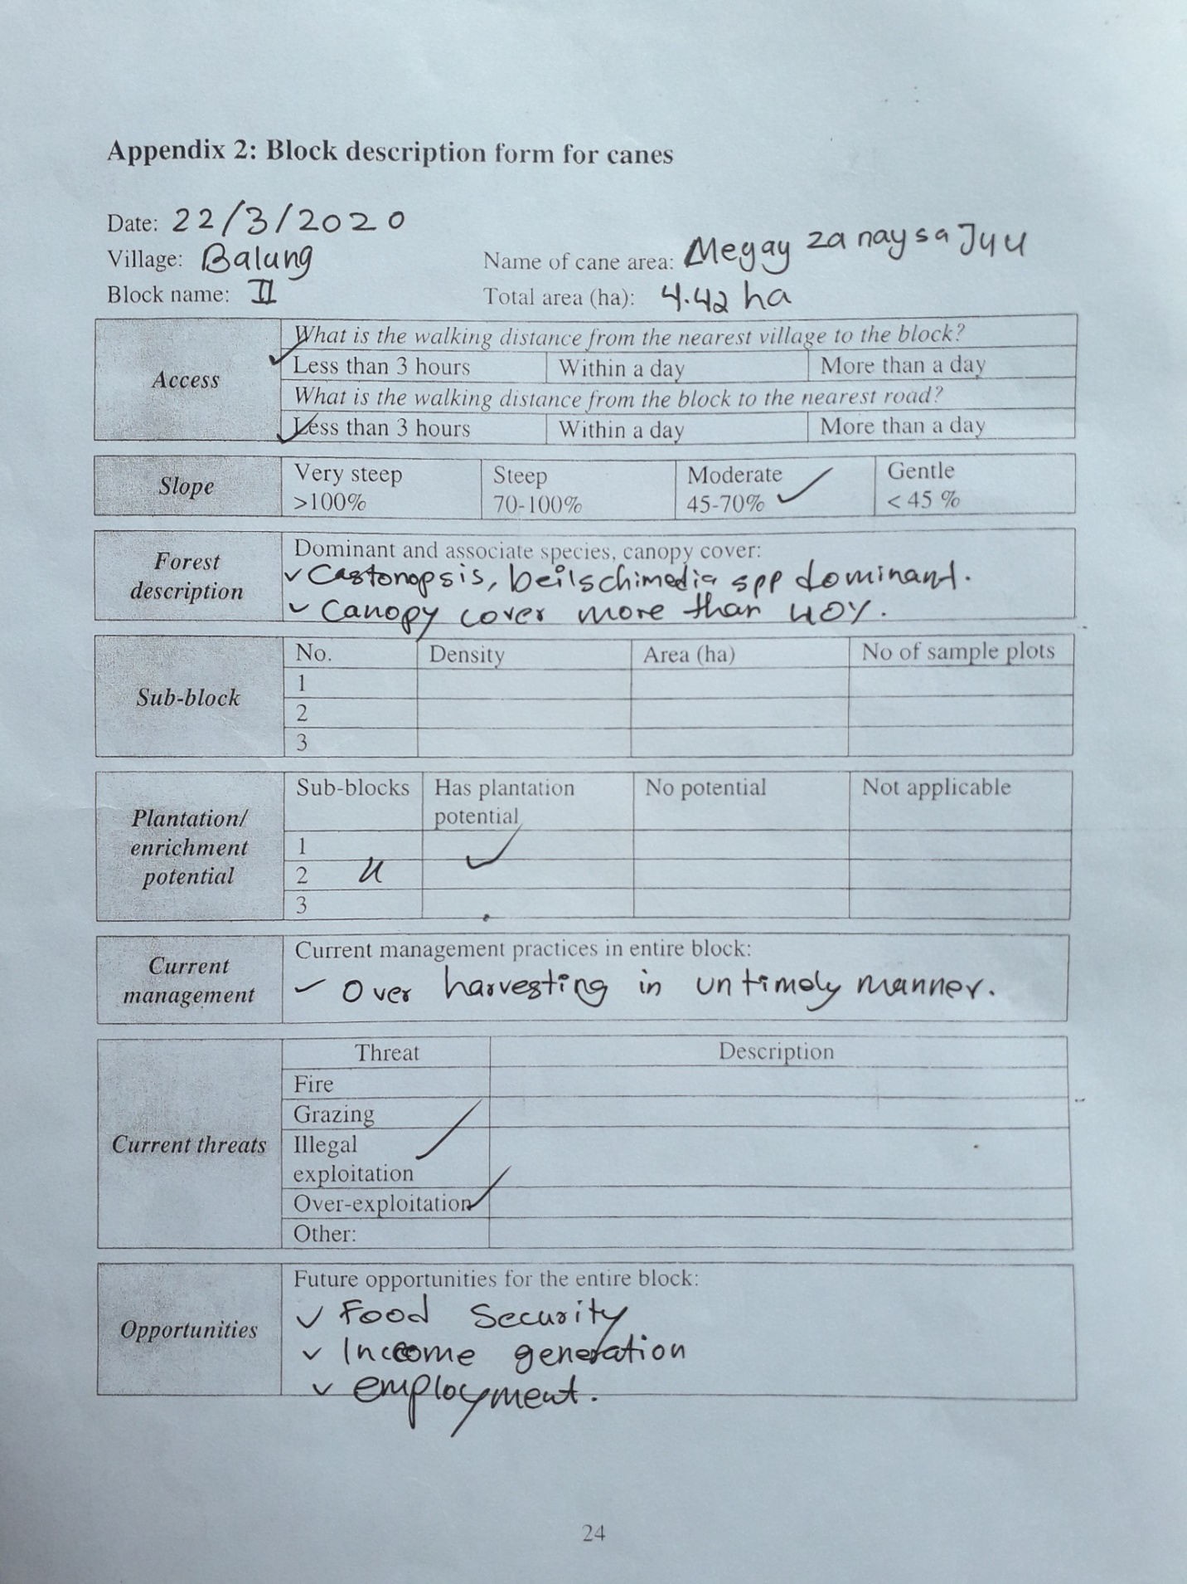
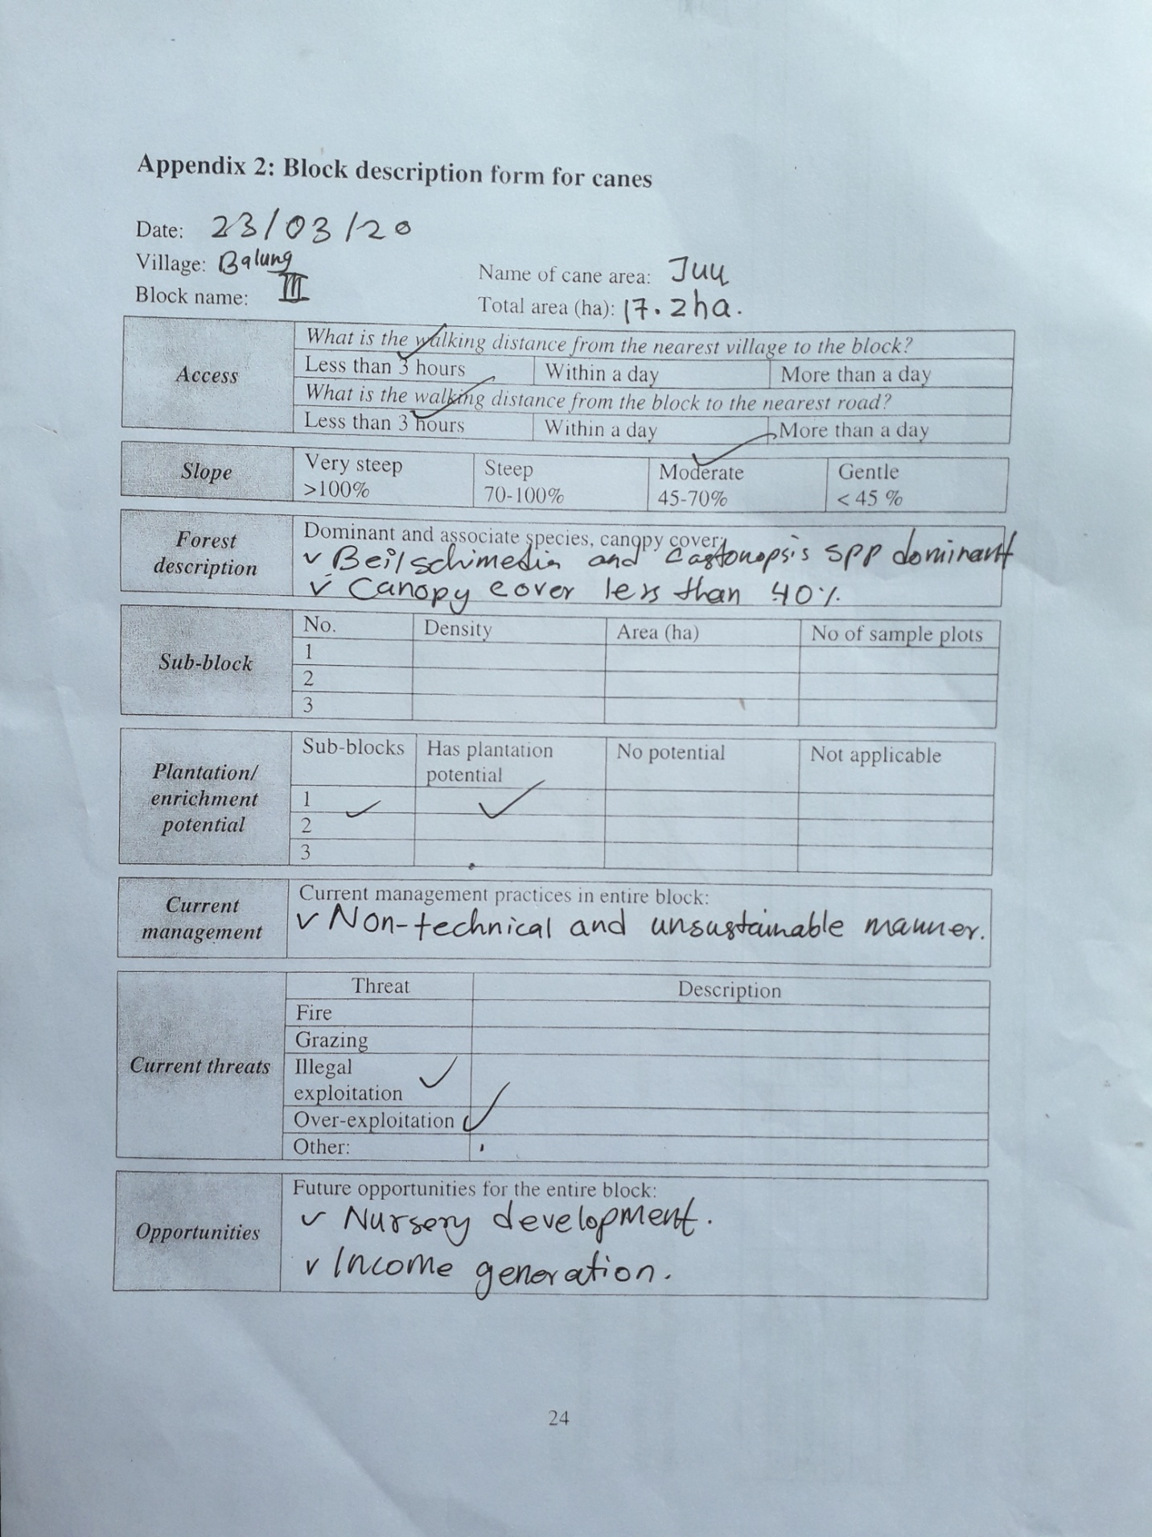

Annexure III: Data Compilation Sheet

Block I
Data Compilation for Block I
Plectocomia himalayana (For canes)
Plot no | L>20m(Cane>10) | L>20m(Cane<10m) | 10-20m | 2-<10m | <2m
6 | 50 | 13+2(stems) | 0 | 0 | 38
7 | 38 | 14+2(stems) | 0 | 0 | 27
8 | 16 | 6+6(stems) | 0 | 0 | 11
9 | 46 | 11+11(stems) | 2 | 0 | 41
Total | 150 | 44+21(stems)=61 | 2 | 0 | 117

Data Compilation for Block I
Plectocomia himalayana (For Shoots)
Plot no | L>20m(Cane>10) | L>20m(Cane<10) | 10-20m | 2-<10m | <2m
6 | 0 | 0 | 23 | 20 | 38
7 | 0 | 0 | 27 | 33 | 27
8 | 0 | 0 | 5 | 2 | 11
9 | 0 | 5+5(stems) | 12 | 35 | 41
Total | 0 | 5+5(stems)=10 | 67 | 90 | 117

Block II
Data Compilation for Block II
Plectocomia himalayana (Canes)
Plot no | L>20m(Cane>10) | L>20m(Cane<10) | 10-20m | 2-<10m | <2m
1 | 11 | 0+1(stems) | 0 | 6 | 3
2 | 24 | 2+4(stems) | 7 | 10 | 40
3 | 20 | 5 | 20 | 7 | 22
4 | 16 | 0 | 38 | 12 | 8
5 | 3 | 0 | 8 | 4 | 4
Total | 74 | 7+6(stems)=13 | 73 | 39 | 77

Data Compilation for Block II
Plectocomia himalayana (Shoots)
Plot no | L>20m(Cane>10) | L>20m(Cane<10) | 10-20m | 2-<10m | <2m
1 | 0 | 0+1 | 0 | 9 | 3
2 | 0 | 1 | 11 | 10 | 40
3 | 0 | 6+3(stems) | 22 | 11 | 22
4 | 0 | 0 | 34 | 15 | 8
5 | 0 | 2+2(stems) | 7 | 5 | 4
Total | 0 | 9+6(stems)=15 | 74 | 50 | 77

Block III
Data Compilation for Block III
Plectocomia himalayana (Canes)
Plot no | L>20m(Cane>10) | L>20m(Cane<10) | 10-20m | 2-<10m | <2m
1 | 9 | 3 | 1 | 8 | 6
2 | 8 | 4+2(stems) | 4 | 4 | 8
3 | 11 | 3 | 2 | 6 | 12
4 | 4 | 4+2(stems) | 1 | 1 | 14
5 | 11 | 7+2(stems) | 10 | 3 | 4
6 | 8 | 7+7(stems) | 15 | 6 | 12
7 | 11 | 6+2(stems) | 14 | 4 | 7
8 | 5 | 6 | 11 | 0 | 10
9 | 3 | 0 | 2 | 3 | 12
10 | 11 | 7+2(stems) | 6 | 5 | 8
11 | 9 | 1 | 4 | 6 | 4
12 | 9 | 0 | 3 | 2 | 18
13 | 8 | 3+3(stems) | 2 | 5 | 6
14 | 12 | 7 | 3 | 2 | 8
15 | 8 | 2 | 9 | 2 | 4
16 | 7 | 1 | 5 | 2 | 5
17 | 5 | 8 | 4 | 2 | 11
18 | 6 | 8+2 | 3 | 2 | 5
Total | 155 | 99 | 94 | 63 | 154

Data Compilation for Block III
Plectocomia himalayana (Shoots)
Plot no | L>20m(Cane>10) | L>20m(Cane<10) | 10-20m | 2-<10m | <2m
1 | 0 | 2+3(stems) | 1 | 5 | 0
2 | 0 | 1+1(stems) | 7 | 2 | 0
3 | 0 | 0 | 5 | 7 | 0
4 | 0 | 0 | 2 | 3 | 0
5 | 0 | 3+3(stems) | 7 | 5 | 0
6 | 0 | 2+4(stems) | 9 | 8 | 0
7 | 0 | 3+4(stems) | 5 | 6 | 0
8 | 0 | 1+2(stems) | 7 | 10 | 0
9 | 0 | 2+1(stems) | 3 | 2 | 0
10 | 0 | 3+2(stems) | 1 | 13 | 0
11 | 0 | 1+3(stems) | 2 | 8 | 0
12 | 0 | 2+2(stems) | 4 | 4 | 0
13 | 0 | 2+2(stems) | 4 | 7 | 0
14 | 0 | 5+3(stems) | 6 | 2 | 0
15 | 0 | 0 | 8 | 0 | 0
16 | 0 | 2+1(stem) | 5 | 3 | 0
17 | 0 | 0 | 7 | 1 | 0
18 | 0 | 5+3 | 5 | 5 | 0
Total | 0 | 68 | 88 | 91 | 0

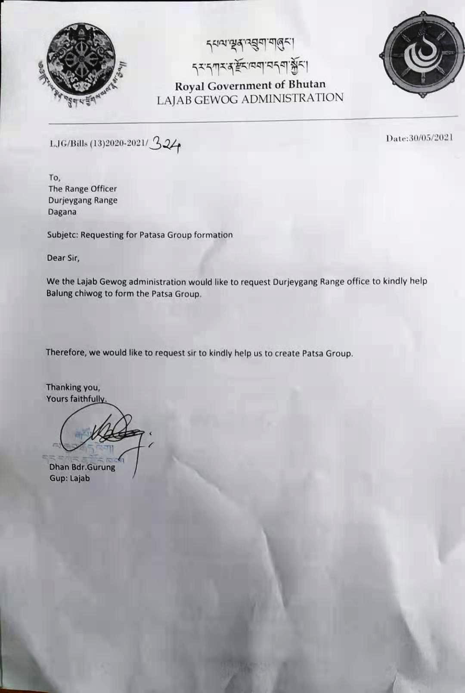
Annexure IV: Application for the establishment of NWFP group from Gewog Administration

Annexure V: List of Non-Wood Forest Product
Sl. No | Name of the NWFP | Local Name
1 | Plectocomia himalayana | Rey
2 | Calamus acanthospathus | Krat
3 | Calamus latifolius | Khran
4 | Zanthoxylum armatum | Timbur (Lh)
5 | Mushroom | Shamu
6 | Elatostema lineolatum | Dumroo
7 | Bamboo spp. | Rashu/Rawa/Glem/Daii
8 | Fern | Nakay

